九上Unit1 Know yourself 单元导入课
Names | Personalities | Dream jobs | Suitable(Yes/No)
课堂活动单
一、Group work
二、Group report
There are people in our group.
A is and . His /Her dream job is .
He is/isn’t suitable for the job because .
B is and . His /Her dream job is .
He is/isn’t suitable for the job because .
C is and . His /Her dream job is .
He is/isn’t suitable for the job because .
D is and . His /Her dream job is .
He is/isn’t suitable for the job because .
…
That’s all for our group report. Thanks for listening.
三、How to be a good monitor
Choose the words from the word bank and give at least one example about each personality.
Word Bank:
modest; energetic; creative; humorous; serious;
organized; confident; helpful ; hard-working

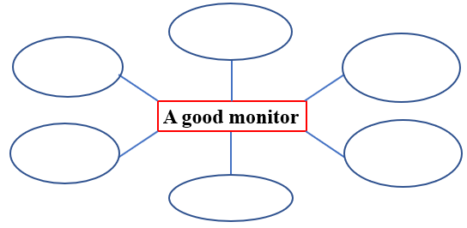
6.
5.
1.
2.
3.
4.

Example:

Example:

Example:

Example:

